**Early findings of SARS-CoV-2 spread and transmission dynamics in Panama from Epidemiological Approach**

**Database description**

* 1079 observations according to date of onset symptoms since February 15 to March 30 (45 days).
* Type of case: 118 Imported and 961 Local. First case of local transmission was on February 17

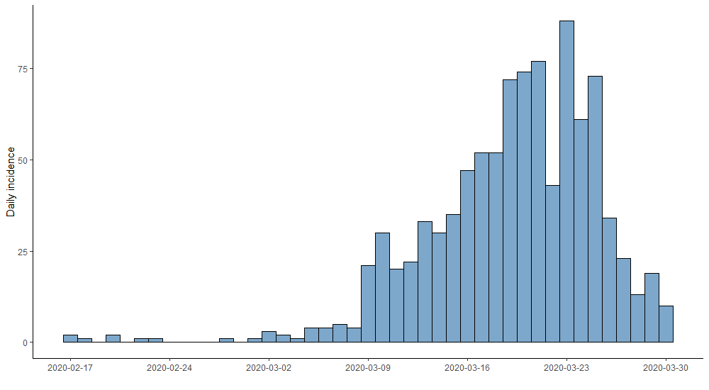

* Age distribution

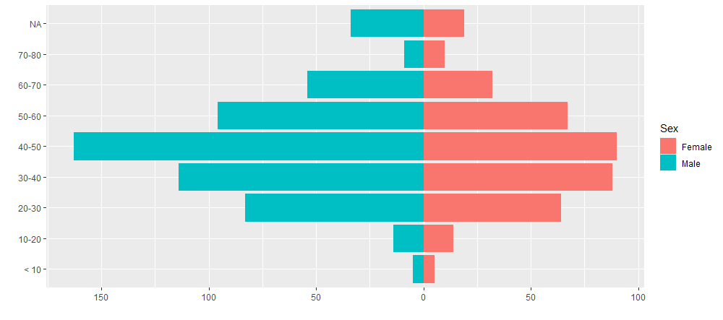

* **Transmission dynamics:**

We assume that epidemic curve might have a bias because the last cases of curve decrease given a false perception of transmissibility decreasing. On the contrary, we corrected this bias erasing last 14 days of observation (5 days of incubation period + 9 days of interval between onset symptoms and diagnostic, approximately). Finally, we evaluate a time interval of 30 days (February 17 – March 17) with 322 cases.

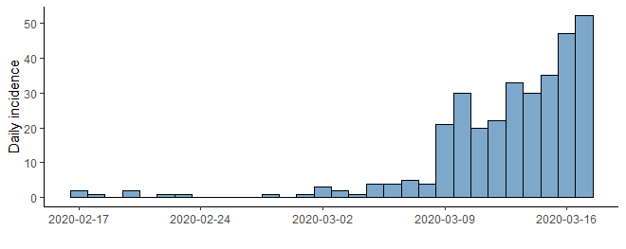

* **Daily growth rate and doubling time**

We estimate daily growth rate by $Ia=e^{r(t-t_{0})}$, where *Ia* are cases cumulative incidence, and *r*, exponential growth rate. Doubling time was calculate by $Dt= {log⁡(2)}/r$. These estimations were calculated with a time interval of 30 days and second time interval between 15 and 30 day.

* Daily growth rate (General): 0.14/day 95%CI (0.10-0.18), doubling time in days 4.78 95%CI (3.77-6.52).
* Daily growth rate (Between 15-30 day): 0.24/day 95%CI (0.18-0.30), doubling time in days 2.79 95%CI (2.26-3.65).

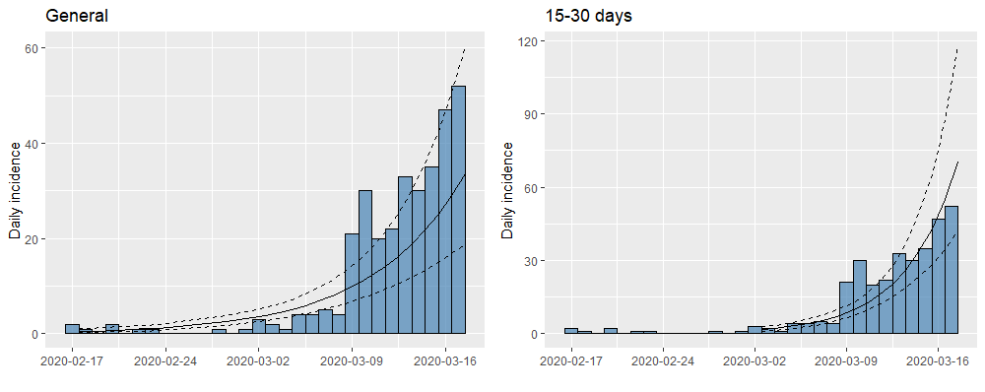

* **Estimations of Basic Reproductive Number (R0)**

For these calculates, we used serial interval described by Nishiura et al. of mean 4.7 days SD: 2.9 days according to gamma distribution (shape = 0.118, scale = 39.52)

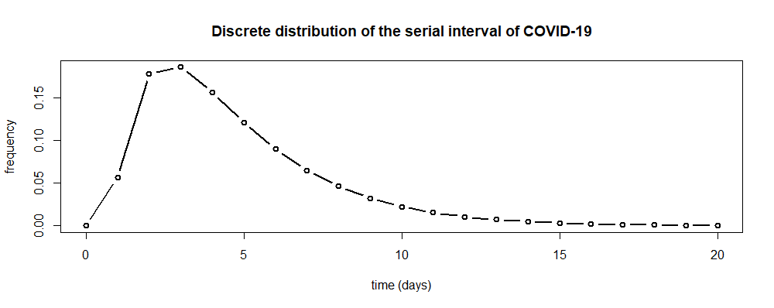

We explored several methods to R0 estimate

1. ***Exponential growth rate method:*** On base of Poisson regression of incidence (Wallinga and Lipsitch) , where R0 is calculated by:

$$R=\frac{1}{M(-r)}$$

Where M is the moment generating function of the (discretized) serial interval. However, it is necessary establish a period in the epidemic curve over which growth is exponential. This period was calculate using the deviance R-squared statistic over a range of possible time periods, where the largest R-squared value corresponds to the period over which model of analysis fitted the data set.

*Estimate:*

* + Time interval (1-30 day): R0: 2.48 95%CI (2.27-2.72) Exponential growth rate: 0.20 95%CI (0.17-0.22)
  + Time interval (25 days: February 21 – March 17): R0: 2.63 95%CI (2.38-2.91) Exponential growth rate: 0.21 95%CI (0.19-0.24)

1. **Maximum likelihood estimation (ML):** This method proposes that the number of secondary cases has a Poisson distribution with expected value R. Given observation of $(N_{0}, N_{1}, …, N_{t})$ incident cases over consecutive time units, and the serial interval, R is calculated by maximizing the log-likelihood

$$LL\left(R\right)=\sum_{t=1}^{T}{\log{(\frac{e^{-s_{t}}S_{t}^{N_{t}}}{N_{t}!}})}$$

Where $S_{t}=R \sum_{i=1}^{t}{N_{t-1}W_{i}}$.

*Estimate:*

* + Time interval (1-30 day): R0: 2.16 95%CI (1.84-2.51)

1. **Likelihood-based estimation using a branching process:** This estimation according to Poisson likelihood by Cori et al. 2013. We start to calculate R0 from 12 cumulative cases. We estimate R0 on interval time since February 18 to February 23.

***Estimate:***

* + R0: 2.64 95%CI (2.36-2.93)

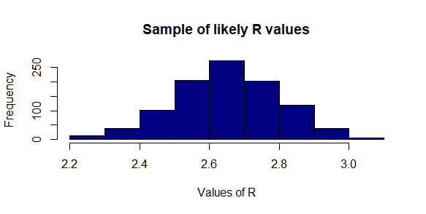

Estimation of Effective reproductive number

Attached this document, 2 databases with estimations of Effective reproductive number according to:

* Cori et al 2013: Assumptions: 1) Calculate from 25 cases of cumulative incidence to Coefficient Variation of 0.2. 2) Time windows of 5 days (this interval was selected because the first assumption restricted to 10 cases of observation) (**Red in the next figure)**
* Sequential Bayesian (Bettencourt and Ribeiro 2008): Assumptions: This interval was estimated in the last 10 day. This short time meet the criteria of exponential growth tendency and none day with zero cases. (**Green in the next figure)**

